Infrastructure > caCORE > caCORE Software Development Kit (SDK)

caCORE Software Development Kit (SDK)

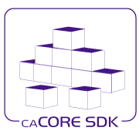
What’s new in Version 4.0 of caCORE SDK?

caCORE SDK 4.0 is a major release w/ key upgrades/improvements including:

- Support for connecting multiple remote services from the same Java API client
- In addition to Enterprise Architect, there is now support for open source UML tool ArgoUML
- Relaxed restrictions on UML Model development
- Tighter integration with Common Security Module for instance and attribute security
- Simplified system generation process
- Enhanced generation of JavaDocs for java classes based on UML model

Overview:
NCICBIIT provides biomedical informatics support and integration capabilities to the cancer research community. NCICBIIT has created caCORE Software Development Kit (caCORE SDK), a data management framework designed for researchers who need to be able to navigate through a large number of data sources. The caCORE SDK generated system is built on the principles of Model Driven Architecture (MDA), n-tier architecture & common API for data access. The use of MDA and n-tier architecture allows for easy access to data, particularly by other applications.

When the caCORE SDK generated system is combined with controlled vocabularies and registered metadata, the resulting software system, called “caCORE-like” system is “semantically integrated” – all exposed API elements have runtime accessible metadata that defines the meaning of the elements using controlled terminology.

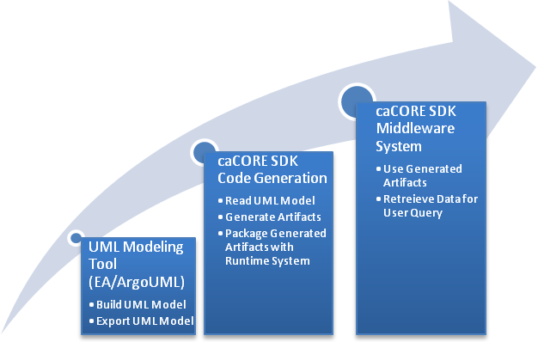

Figure: SDK System Generation Process

caCORE SDK Modules
The caCORE SDK is comprised of two modules: a “Code Generation Module” which accepts a UML model as input and produces java classes and other artifacts that can be used by standard client APIs to access data; and “Middleware Module” that provides the actual infrastructure and standard client APIs to access the underlying data system thru n-tier architecture

Benefits of Using the caCORE SDK
- Consistent UML representation of the data – Users of the caCORE SDK are required to represent their data management framework in UML format. The same UML model is used further downstream by tools for semantic integration and registering metadata
- Rapid data service generation – The SDK can generate caBIG silver-level compatible system quickly from the UML model. Once the UML model and the database are ready, the data service can be generated in a matter of hours. Manually building the application from the ground up can take several months to achieve the same functionality.
- Uniform way to access data – SDK-generated systems provide uniform access to the data stores through standard client APIs that use the UML domain model. So, a single client application can be written to access multiple SDK generated systems easily.
- Query using information model – SDK-generated systems use Query by Example format which allow for easy programmatic access of systems using standard client APIs and traversal of the UML model.
- Integration with caGrid – SDK generated systems can be easily integrated with the caGrid using Introduce Toolkit without requiring any additional code.
Download
NCICBIIT provides access to the caCORE SDK at our public GForge site. The distribution contains the major components of the SDK, Developers Guide and Release Notes as well as most of the additional software required to utilize the toolkit. Download caCORE SDK
The other required software tools not supplied is listed in the table below. Users are required to download and install the required software prior to running the caCORE SDK
Description | Software | Version | URL
The J2SE Software Development Kit (SDK) supports creating J2SE applications | JDK | 1.5.0_11  or higher | http://java.sun.com/j2se/1.5.0/download.html
UML Modeling Tool† | Enterprise Architect (EA) | 6.0  or higher | http://www.sparxsystems.com.au/
UML Modeling Tool† | ArgoUML | 0.24  or higher | http://argouml.tigris.org/
Database Server† | Oracle | 9i | http://www.oracle.com/technology/products/oracle9i/index.html
Database Server† | MySQL | 5.0.27 | http://dev.mysql.com/downloads/mysql/5.0.html
Application Server† | JBoss | 4.0.5 | http://labs.jboss.com/jbossas/downloads
Application Server† | Tomcat | 5.5.20 | http://tomcat.apache.org/download-55.cgi
Build Tool | Ant | 1.6.5  or higher | http://ant.apache.org/bindownload.cgi
† Only one is required.
Table: Minimal software requirements

Mailing Lists
NCICBIIT maintains the following mailing lists as discussion forums with caCORE users and developers:
- Users' Discussion Forum , for users of the caCORE Java API, Web Services, and/or HTTP-XML APIs.
Software Support
NCICBIIT encourages you to submit questions and bug reports via NCICBIIT Application Support .

SDK Documentation
- caCORE SDK Developers Guide Combines the previous SDK Programmer’s and Installation and Basic Test Guides. Contains detailed instructions on the use of the SDK and how it helps create a caCORE like software system, as well as detailed instructions on how to install, build, deploy, and test your SDK Installation.
- caCORE SDK Migration Guide Contains detailed instructions on how to migrate from SDK v3.2.x.
- Release Notes

Content for http://ncicb.nci.nih.gov/download/

caCORE SDK |  | Download |  | Learn More

NCICBIIT provides biomedical informatics support and integration capabilities to the cancer research community. NCICBIIT has created caCORE Software Development Kit (caCORE SDK), a data management framework designed for researchers who need to be able to navigate through a large number of data sources. The caCORE SDK generated system is built on the principles of Model Driven Architecture (MDA), n-tier architecture & common API for data access. The use of MDA and n-tier architecture allows for easy access to data, particularly by other applications.

When the caCORE SDK generated system is combined with controlled vocabularies and registered metadata, the resulting software system, called “caCORE-like” system is “semantically integrated” – all exposed API elements have runtime accessible metadata that defines the meaning of the elements using controlled terminology

Infrastructure > User Groups

User Groups

Core Infrastructure Group Listservs
The Core Infrastructure group maintains and monitors several discussion listservs related to its projects. Subscribers can ask questions of the development team, receive the latest announcements, and exchange stories with other caCORE users.
- cabio_users : Discuss issues related to the usage of the caBIO software and caCORE APIs.
- cabio_developers : For those extending caBIO.
- cacore_sdk_users-l : Discuss issues related to using and extending caCORE SDK software
- cadsr_users : Discuss issues related to the usage of the caDSR and metadata standards.
- ncievs-l : Discuss the NCI EVS resource and other terminology issues.
- cabig_arch-l : caBIG™ Architecture Workspace.
- cabig_vcde-l : caBIG™ Vocabularies and Common Data Elements Workspace.
Cancer Data Standards Repository (caDSR)
Up-to-date information and messages concerning the caDSR are sent to a listserv hosted by the NIH. Please subscribe to the list at http://list.nih.gov/archives/cadsr_users.html
Enterprise Vocabulary Services (EVS)
The latest information and messages about the EVS are sent out to a distribution list hosted by the NIH. Please subscribe to the list at http://list.nih.gov/archives/ncievs-l.html
Common Security Module (CSM)
NCICBIIT maintains the following mailing lists as discussion forums with users and developers of caBIO and the CSM:
- Users' Discussion Forum , for users of the caBIO Java, SOAP, and/or HTTP-XML APIs.
- Developers' Discussion Forum , for developers who are extending the API, adding additional data sources, and/or enhancing the existing source code.
caCORE Software Development Kit (SDK)
NCICBIIT maintains the following mailing lists as discussion forums with users and developers of caCORE SDK:
- Users' Discussion Forum , for users of the caCORE SDK who are using SDK generated system and/or extending the SDK generated systems.

